Method-3 : Star-Delta Transformation
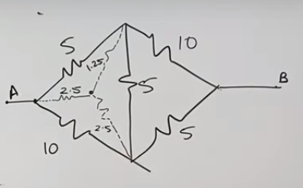
Two Deltas are present, convert any one into Star form; introduce a junction b/w the three junctions, write the resistances on those junctions are remove the existing Delta form resistances
now calculate the equivalent resistance
